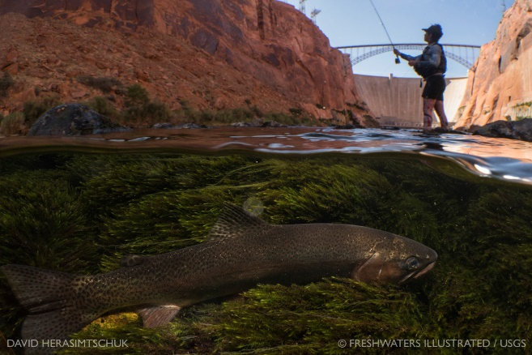Anya Nova Metcalfe

***Ecologist***

[ametcalfe@usgs.gov](mailto:ametcalfe@usgs.gov)

Office: (928) 556 7049

Twitter: @anyanovaya

j01158552255 N Gemini Dr, Flagstaff, AZ 86001

**Education:**

**Northern Arizona University Flagstaff, AZ**

M.S. Biological Sciences **2018**

Thesis: Aquatic insect distribution in the Colorado River Basin

**Prescott College Prescott, AZ**

B.A. Environmental science with emphasis in aquatic resources **2012**

Minor in Adventure Education Senior thesis: Biogeography of aquatic beetles in springs of the Colorado River Watershed

**Universidad de Guanajuato Guanajuato, Mexico**

Foreign exchange student, Hydrology department **2010**

**Work Experience:**

**U.S. Geological Survey 2012-*present***

**Grand Canyon Monitoring and Research Center & Southwest Biological Science Center** Flagstaff, AZ

**Ecologist GS 9 Series 0408**

-Managed a citizen science project in the Colorado River watershed that spanned 7 states

-Using expert knowledge of Colorado River Basin aquatic insect fauna to identify taxa to species

-Processed more than 1799 light trap samples (979,430 insects) as of 9/3/2019

-Presenting research to and working alongside resource managers

-Spent more than 300 days in remote sections of Grand Canyon and Glen Canyon collecting aquatic and terrestrial invertebrate specimens using a myriad of traps and methods including drift nets, Hess samplers, ponar, light traps, sticky traps, and emergence traps

-Inspiring youth through scientific outreach

-Curating and managing a small in-house entomological collection

-Led a 2 day workshop on Trichoptera identification

**U.S. Geological Survey July - October 2020 Water Mission Area** Remote

**Social media strategist (10 week detail)**

-Managed Instagram account (@USGS_streamgages) for USGS Water Mission Area

-Developed daily social media content for national distribution

**Museum of Northern Arizona 2012-2013**

**Curatorial Assistant** Flagstaff, AZ

-Handling, sorting, labeling, and identifying entomological specimens for museum collections

-Organizing and maintaining a collection of more than 200,000 specimens

-Collected over 2,000 invertebrate specimens in the field

-Overseeing and organizing museum volunteers

**Summer Among the Peaks Discovery Camp**

**Bug Camp Instructor**  July 2012, July 2013

-Instructing 10 students during week long bug camps with daily field trips

**Grand Canyon Wildlands Council 2012-2014**

**Lead Technician** Flagstaff, AZ -Leading collection of interdisciplinary datasets on flora, fauna, hydrology, and human impact

-Wrote technical field reports describing field sites and sampling efforts

**Springs Stewardship Institute 2011-2012**

**Field Technician** Flagstaff, AZ

-Collected invertebrate specimens from over 40 springs on public lands in AZ and NV

-Gathering interdisciplinary datasets on the biology, geology, hydrology, and archaeology of springs

-Aided in the facilitation of 2 workshops for spring monitoring and restoration.

**US Forest Service/ Americorps 2010**

**Interpretation Internship** Santa Fe National Forest, NM -Created and delivered 8 educational programs for mixed-age audiences

-Designed and illustrated a field guide to freshwater macroinvertebrates

-Made 2,000+ contacts with forest visitors

**Additional Scientific Research and Field Experience:**

**Field Technician – Monitoring fish populations Glen Canyon/CO River** 2012-presentUSGS/GCMRC

**-**Handling, identifying, sexing, measuring, and tagging fish

**-**With a team, processing up to 5,000 fish a night (collected by electroshocking)

**-**Working nocturnally (8 pm – 4 am)

**Trip participant – Sesquicentennial Colorado River Exploratory Expedition** 2019

USGS/UWY

-Selected as a USGS participant in river trip celebrating 150 years since Powell Expedition

**Field Technician** 2012

Seeds of Success/Northern Arizona University -Identifying and collecting seeds from native plants in Southern Utah

-Using a field press to collect voucher specimens for Flagstaff herbarium and Smithsonian collections

**Field Assistant – Monitoring populations of Humpback Chub in the Colorado River**  Apr 2012, Sept 2012

US Fish and Wildlife Service

-Capturing fish using hoop and trammel nets

-Handling, identifying, sexing, measuring, and PIT tagging fish

**Elk calf-mortality study** at **the Valle Caldera National Wildlife Refuge, NM** June - July 2011

-Tagging calves with ear tag transmitter, locating wildlife using telemetry, appropriately handling calves

**Independent research project on benthic invertebrates of the Colorado River and its tributaries** 2011

**-**Sampled insects from ten tributaries and 9 sites along the Colorado River during a 21 day river trip

**-**Authored an unpublished 8 page report and presented at Prescott College Grand Canyon Symposium

**Collecting baseline resource data in remote technical slot canyons of Grand Canyon** 2013

**-**Collecting data on the ecology, hydrology, geology, and recreation impacts of technical slot canyons

**-**Rappeling as much as 200 ft/pitch, swimming in cold water, hiking long distances, and packrafting

***Colpomenia tuberculata* as a microhabitat in Estero Santa Rosa, Sonora, Mexico** 2011

-Collecting, identifying, and recording the marine macroinvertebrates that live within a brown alga

**-**Collection methods required hiking, kayaking, snorkeling, and extensive wading

-Co-wrote a 15 page unpublished report

**Electro-shocking with a backpack unit to remove invasive fish** Intermittent2010-2015

-Participated in 14 collective days of fish removal in Prescott National Forest, AZ, Santa Fe National Forest, NM and Bright Angel Creek in Grand Canyon National Park, AZ.

**Monitoring tamarisk beetle populations on the Colorado River** 2011

-Assisting a masters student (CSU) in collecting tamarisk beetles in Grand Canyon

**Surveying beaver population in the Verde River, AZ** 2010

-Three weeks locating, surveying, and monitoring beaver dams for the Nature Conservancy

**Verde River and Butte Creek Restoration Field Technician** 2009

**Volunteer Work:**

**Co-instructor for Girls Who Code** 2018

**-**assisted middle school girls with coding project in after-school club

**Giving presentations at public schools** 2011-present

**-**>6 presentations on entomology for Flagstaff Festival of Science (annual)

-2 hour presentation on Environmental Careers in a rural school district (Dewey, AZ)

**Guest teacher for ecology club “Los delfines jovenes” in Bahia de Kino, Sonora, Mexico** 2011

-Preparing and facilitating lessons on marine biology in Spanish for middle school students

**Founder and president of marine conservation group “Make a Wave” in Pompano Beach, FL**  2007-2009

-Initiated and led 64 member club for 3 years

-Received grant for $2,000 of water quality testing equipment & training

-Led weekly sampling and analysis of a local inlet for presence of E. Coli for one year

-Featured in 3 local newspapers and the magazine Teen Vogue

**Instructor and activities coordinator at children’s museum “Young @ Art”** 2006-2008

**-**Volunteered 300+ hours

-Assisted in organization of 3 events and fundraisers

**Grants & Recognition**

*Federal agencies*

QRP USGS/USFWS grant to continue research on aquatic insects of upper Colorado River Basin, 2018

partnership with Upper Colorado Endangered Fish Recovery Program ($75,000)

Dinosaur National Monument grant to continue Citizen Science efforts in park ($10,000) 2018

Dinosaur National Monument grant to begin a Citizen Science monitoring project 2016

for aquatic insects ($33,000)

Rhode Island School of Design (RISD) Maharam STEAM fellowship to collaborate with 2014

RISD M.F.A. student ($5,000)

*Societies & Organizations*

Western Bat Working Group Bob Berry Award($2,000 training & new detector) 2015

Aldo Leopold Land Ethic Leader Workshop (Land Steward Fellowship, $200 training) 2012

Surfrider Foundation ($2,000 marine water testing equipment and training) 2007

*Academic*

AmeriCorps Award Recipient, Student Conservation Association ($1200) 2011

Community Service Education Award ($1200) 2011

Sustainability Scholar, The North American Mobility Program ($5000) 2010

Prescott College Designated Class Archivist ($300 photography award) 2010

John Wesley Powell Scholarship ($8,000 for academic achievement) 2009 Environmental and Social Justice Scholarship ($8,000 for community leadership) 2009

George Snow Foundation Scholar ($12,000 for academic achievement) 2009

Ford Salute to Education Scholar ($1,000 for academic achievement) 2009

Charles Franklin Parker Scholar($4,000 for community leadership) 2009

**Specialized Training:**

* + Spatial Statistical Network Modeling (Boise, ID) 2019
  + Bayesian Modeling (Flagstaff, AZ) 2019
  + Swiftwater certified (NOLS) 2017
  + Titley ANABAT software training (Raleigh, NC) 2015
  + Trichoptera of the Southwest Workshop (Flagstaff, AZ) 2014
  + Springs Restoration Workshop (Las Vegas, NV) 2012
  + Wilderness First Responder Current, Since 2011
  + Grand Canyon Semester selected participant (Prescott College, AZ) 2011
  + Aldo Leopold Land Ethic Leader Workshop (Albuquerque, NM) 2011
  + Completed B-3 Combination Helicopter/Airplane Safety Course (DOI)2010

**Scientific Publications**

Patrick, C., Anderson, K., Brown, B., Hawkins, C., Metcalfe, A., Saffarinia, P., Siqueira, T., Swan, C., Tonkin, J., & Yuan, L. 2021. The application of metacommunity theory to the management of riverine ecosystems. WIREs Water.

Metcalfe, A., Muehlbauer, J., Ford, Morgan, & Kennedy, T. 2021. Colorado River Basin. *In press.* In Delong, M. & T. Jardine (Eds.). Rivers of North America (2nd ed.). Wiley.

Metcalfe, A., Muehlbauer, J., Kennedy, T., Yackulic, C., Dibble, K., & Marks, C. 2020. Net-spinning caddisfly distribution in large regulated river. Freshwater Biology.

Metcalfe, A., Kennedy, T., Marks, C., Smith, A., & Muehlbauer, J. 2020. Spatial genetic structuring of a widespread aquatic insect in the Colorado River Basin: evidence for *Hydropsyche oslari* species complex. Freshwater Science 39 (2)

Metcalfe, A., Muehlbauer, J., Ford, Morgan, & Kennedy, T. 2020. Bug Flows: Don’t count your midges until they hatch. The Boatman’s Quarterly Review 32(4): 8-11.

Metcalfe, A. 2019. Adult net-spinning caddisfly (*Hydropsyche* spp.) catch rates and morphology from large rivers of the southwestern United States, 2015-2016: U.S. Geological Survey data release. Available from [<https://doi.org/10.5066/P94N7GI9](https://doi.org/10.5066/P94N7GI9).

Metcalfe, A. 2019. Locality based caddisfly (*Hydropsyche oslari*) sampling data and CO1 sequences from the southwestern United States, 2013-2016: U.S. Geological Survey data release. Available from [<https://doi.org/10.5066/P93GMB1Y](https://doi.org/10.5066/P93GMB1Y).

Nathan, L., Mamoozadeh, N., Tumas, H., Gunselman, S., Klass, K., Metcalfe, A., Edge, C., Waits, L., Spruell, P., Lowery, E. & Connor, E. 2019. A spatially-explicit, individual-based demogenetic simulation framework for evaluating hybridization dynamics. Ecological Modelling 401: 40-51.

Metcalfe, A. 2018. Aquatic insect distribution in the Colorado River Basin. Masters Thesis. Northern Arizona University. Available from Proquest ([<https://search.proquest.com/docview/2051910485](https://search.proquest.com/docview/2051910485))

Eitzel, M., Cappadonna, J., Santos-Lang, C., Duerr, R., West, S., Virapongse, A., Kyba, C., Bowser, A., Cooper, C., Sforzi, A., Metcalfe, A., Harris, E., Thiel, M., Haklay, M., Ponciano, L., Roche, J., Ceccaroni, L., Shilling, F., Dörler, D., Heigl, F., Kiessling, T., Davis, B., & Jiang, Q. 2017. Citizen science terminology matters: Exploring key terms. Citizen Science: Theory and Practice 2: 1-20. DOI: 10.5334/cstp.96.

Kennedy, T., Muehlbauer, J., Yackulic, C., Lytle, D., Miller, S., Dibble, K., Kortenhoeven, E., Metcalfe, A., & Baxter, C. 2016. Flow management for hydropower extirpates aquatic insects, undermining river food webs. BioScience 77: 561–575. DOI: 10.1093/biosci/biw059. **BioScience Editor’s Choice and featured in Press Releases by USGS, Oregon State U., Conservation Magazine, and others.**

Metcalfe, A., Kennedy, T., & Fritzinger, C. 2016. Moth Mystery Hour. The Boatman’s Quarterly Review 27(4): 15-16.

Metcalfe, A., Kennedy, T., & Muehlbauer, J. 2016. Phenology of the adult angel lichen moth (Cisthene angelus) in Grand Canyon, USA. The Southwestern Naturalist 61: 233–240. DOI: 10.1894/0038-4909-61.3.233

Metcalfe, A., Kennedy, T. & Muehlbauer, J. 2016. Angel lichen moth abundance and morphology data, Grand Canyon, AZ, 2012. US Geological Survey Data Release. DOI: 10.5066/F7154F5S

**Manuscripts in** **review**

Metcalfe, A., Kennedy, T., Mendez, G., & Muehlbauer, J. 2021. Applied citizen science in freshwater research. *In press.* Invited primer for WIREs water.

**Major conference presentations (as lead author only)**

Metcalfe, A., Muehlbauer, J., Kennedy, T., Yackulic, C., Dibble, K., & Marks, C. 2020. (Poster). Net-spinning caddisfly distribution in a large regulated river. Ecological Society of America annual meeting. Virtual.

Metcalfe, A., Kennedy, T., Muehlbauer, J., Marks. J. 2019. Gene flow among net-spinning caddisfly populations in the Colorado River Basin. Biennial Conference of Science and Management on the Colorado Plateau. Invited speaker for special session “Evaluating the effects of flow and connectivity on river ecosystems.” Flagstaff, AZ.

Metcalfe, A., Kennedy, T., Muehlbauer, J. 2019. Genetic diversity of a widespread net-spinning caddisfly (Hydropsyche oslari). Society Freshwater Science annual meeting. Salt Lake City, UT.

Metcalfe, A., Kennedy, T., Muehlbauer, J. 2019. Genetic diversity of a widespread net-spinning caddisfly (Hydropsyche oslari). (Poster). Glen Canyon Dam Adaptive Management Program annual reporting meeting. Phoenix, AZ.

Metcalfe, A. 2018. Shedding light on aquatic insects of the Colorado River Basin with citizen science. The 39th annual researchers meeting for the Upper Colorado River Endangered Fish & Recovery Program. Vernal, UT.

Metcalfe, A. 2018. Shedding light on aquatic insects of the Colorado River Basin with citizen science. Glen Canyon Dam Adaptive Management Program annual reporting meeting. Phoenix, AZ.

Metcalfe, A. Mixon, R. 2017. Do dams affect bat diets? Western Bat Working Group annual meeting. Fort Collins, CO.

Metcalfe, A., Kennedy, T., Muehlbauer, J. 2017. The Grand Beyond: Aquatic foodbase of the Upper Colorado River Basin (Poster). Glen Canyon Dam Adaptive Management Program annual reporting meeting. Phoenix, AZ.

Metcalfe, A., Kennedy, T., Muehlbauer, J. 2017. The Colorado River Basin: Aquatic insect diversity and distribution in a fragmented riverscape. Society for Freshwater Science annual meeting. Raleigh, NC.

Metcalfe, A., Kennedy, T., Muehlbauer, J. 2016. Compounding Impoundments: aquatic insect distribution and emergence in a fragmented riverscape. Society for Freshwater Science annual meeting. Sacramento, CA.

**Other, invited, scientific presentations**

Metcalfe, A. 2019. What are Bug Flows? Field presentation to the Coconino County Watershed Partnership. Page, AZ.

Metcalfe, A., Kennedy, T., Muehlbauer, J. 2019. Colorado River ecosystem response to the 2018 Bug Flow Experiment released from Glen Canyon Dam. Grand Canyon River Guides Training Seminar. Marble Canyon, AZ.

Metcalfe, A. 2017. What is Citizen Science? Consultative Group for Biological Diversity annual meeting. Flagstaff, AZ.

Metcalfe, A., Kennedy, T., Muehlbauer, J. 2017. Comparative emergence studies in the upper basin using citizen science light traps. Western Area Power Administration webinar. Remote.

Metcalfe, A. 2016. Big River Bugs: A Citizen Science Approach. Moab Festival of Science. Moab, UT.

Metcalfe, A. 2016. Aquatic insect diversity and distribution in the Colorado River Basin. Center for Ecosystem Science and Society seminar. Flagstaff, AZ.

**External media coverage**

Society for Freshwater Science (2020) Guest for Making Waves podcast “River guides are science guides” <<https://freshwater-science.org/news/making-waves-ep-49>>

USGS (2019) Guest for podcast about Citizen Science. “Outstanding in the Field: Citizen Science – Your Data in Action” <<https://www.usgs.gov/media/audio/outstanding-field-ep-2-citizen-science-your-data-action>>

Arizona PBS (2019) Interviewed for documentary about the future of Grand Canyon National Park. <https://azpbs.org/2019/02/beyond-the-rim-the-next-100-years-of-grand-canyon-national-park/>

National Geographic (2016) Interviewed for “At 17 million tears old, Grand Canyon still has lessons to teach.” <<https://video.nationalgeographic.com/video/short-film-showcase/00000156-e673-dbd5-add6-fff3e6d30000>>

Scientific American (2019) Article about conducting aquatic ecology research in Grand Canyon. <https://www.scientificamerican.com/article/re-engineering-the-colorado-riverto-save-the-grand-canyon >

Associated Press, picked up by The New York Times, The Washington Post, US News and World Report, and others (2018) Story describing the Bug Flows experiment <https://apnews.com/accec230d442406fa7bedf4af219c5d1>

Bureau of Reclamation (2018) Official press release describing Bug Flows experiment <https://www.usbr.gov/newsroom/newsrelease/detail.cfm?RecordID=62133 13)>

Undark Magazine (2018) Essay about conducting aquatic ecology research in Grand Canyon <https://undark.org/article/wilo-doyle-colorado-river-insects/>

NAU (2017) Featured on Center for Ecosystem Science and Society page < <http://ecoss.nau.edu/team/anya-metcalfe/>>

National Public Radio KNAU (2017) Story about *Cisthene angelus* paper. <<https://www.knau.org/post/earth-notes-angel-lichen-moths>>

Science Magazine (2016) Scientific reinterpretation of the BioScience hydropeaking paper. <http://science.sciencemag.org/content/353/6304/1099>

Arizona Daily Sun (2016) Story about BioScience hydropeaking paper. <http://azdailysun.com/news/local/dam-management-plan-aims-to-boost-native-fishbugs/article_8f2a949c-03ee-5f96-86b4-eda52fd0ffbf.html>

National Public Radio KNAU (2016) Story about BioScience hydropeaking paper. <http://knau.org/post/study-hydropower-decimates-aquatic-insects-coloradoriver#stream/0>

High Country News (2016) Reinterpretation of BioScience hydropeaking paper. <https://www.hcn.org/issues/48.12/new-measures-could-reduce-glen-canyon-damsimpact-on-the-grand-canyon-a-bit >

Columbia Basin Fish & Wildlife News Bulletin (2016) Summary of BioScience hydropeaking paper. <http://www.cbbulletin.com/436660.aspx>

American Fisheries Society (2016) Summary of BioScience hydropeaking paper. <https://fisheries.org/2016/05/citizen-science-reveals-how-river-food-webs-areaffected-by-hydropower-practices/ =>

Conservation Magazine (2016) Summary of BioScience hydropeaking paper. <http://conservationmagazine.org/2016/05/simple-trick-make-dams-less-damagingriver-ecosystems/>

USGS (2016) Official press release for BioScience hydropeaking paper. <https://www.usgs.gov/news/river-food-webs-threatened-widespread-hydropowerpractice>

Oregon State University (2016) Official press releases for BioScience hydropeaking paper. <https://today.oregonstate.edu/archives/2016/may/hydropeaking-river-waterlevels-disrupting-insect-survival-river-ecosystems>

BioScience (2016) Editor’s choice selection for BioScience hydropeaking paper. <http://bioscienceaibs.libsyn.com/hydroelectric-dams-kill-insects-wreak-havoc-withfood-webs>

**Students & Technicians Mentored**

*Diana Valentin* Northern Arizona University, Environmental Sciences. Summer 2021.

-Internship supervisor for ENV 408, scientific illustration

*Gabriella Mendez* Northern Arizona University, Environmental Sciences. Spring 2021.

-Internship supervisor for ENV 408, scientific illustration

*Alexander Gonzalez* Northern Arizona University, Environmental Sciences. Fall 2020.

-Internship supervisor for ENV 408 and mentor in caddisfly taxonomy

*Emilio Saladino* Northern Arizona University, Environmental Sciences. 2019 – 2020.

-Internship supervisor for ENV 408 and mentor in Science outreach

*Brece Hendrix* Northern Arizona University, Forestry., Biological technician 2015-2018.

-Supervisor and mentored in aquatic entomology

*Kate Aitchison* Rhode Island School of Design. 2015-2016.

-Collaborator in science communication for Maharam STEAM Fellowship

**Professional Service**

* Peer reviewer for Environmental Entomology, Journal of Environmental Management, Journal of Applied Ecology, and other scientific publication outlets
* Flagstaff Science Center Outreach Committee since 2013
* Classroom speaker for Flagstaff Festival of Science since 2012
* Volunteer with Ecological Society of America Career Central

**Additional Skills and Interests:**

* Trilingual (Russian, Spanish, English)
* Outdoor enthusiast: experienced river runner, hiker, canyoneer, and rock climber
* Certified Wilderness First Responder since May 2011
* Proficient with R, GIS, Inkscape, Github, Microsoft Office, and a suite of genetic analysis tools

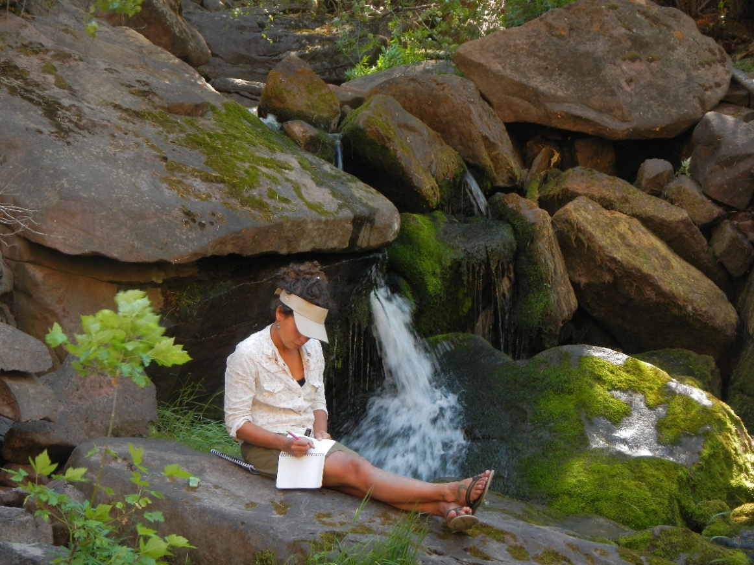

*Header photo by Freshwaters Illustrated*